**Web Programming**

Lab - 6

CSS

Name: Sushen Grover

Reg No: 23BCE1728

Slot: L11+L12+L31+L32

Class No: CH2024250502774

Course Code: BCSE203E

Faculty: Dr. L.M. Jenila Livingston

Question 1:

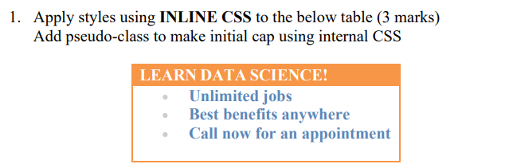

Code:

HTML

<!DOCTYPE html>

<html lang="en">

<head>

    <meta charset="UTF-8">

    <meta name="viewport" content="width=device-width, initial-scale=1.0">

    <title>23BCE1728</title>

    <link rel="stylesheet" type="text/css" href="ex1.css">

    <style>

        li::first-letter{

            text-transform: capitalize;

        }

    </style>

</head>

<body>

    <h1>Exercise 6A</h1>

    <table style="border-collapse: collapse;border: 3px solid orange;">

        <tr>

            <th style="color: white;background-color: orange;">LEARN DATA SCIENCE!</th>

        </tr>

        <tr>

            <td style="width: 350px;">

                <ul>

                    <li style="color: grey;"><span style="color: rgb(52, 52, 255);"><b>unlimited jobs</b></span></li>

                    <li style="color: grey;"><span style="color: rgb(52, 52, 255);"><b>best bebefits anywhere</b></span></li>

                    <li style="color: grey;"><span style="color: rgb(52, 52, 255);"><b>call now for an appointment</b></span></li>

                </ul>

            </td>

        </tr>

    </table>

</body>

</html>

Output:

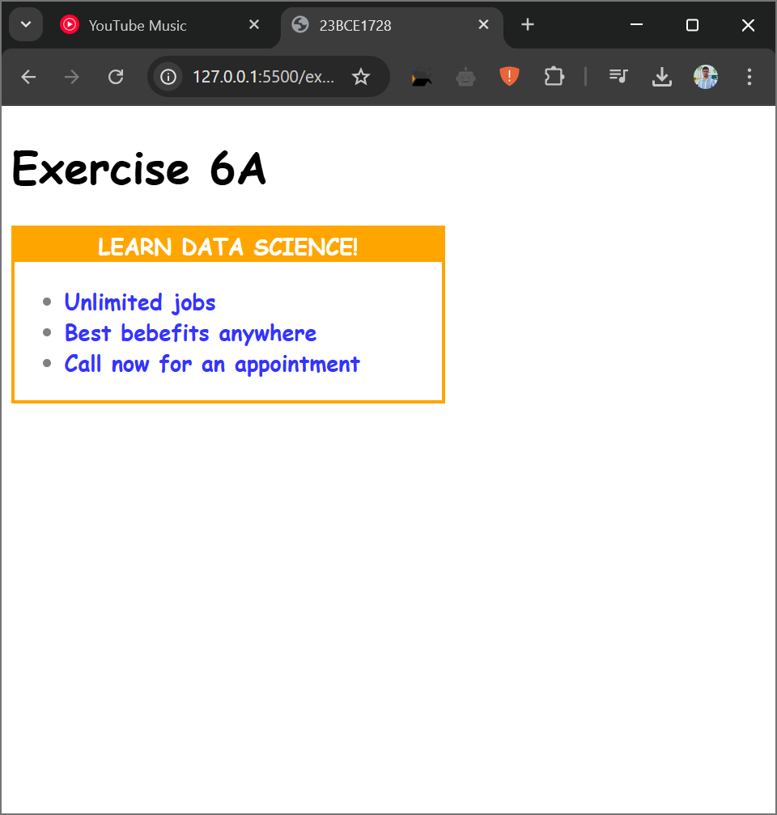

Question 2:

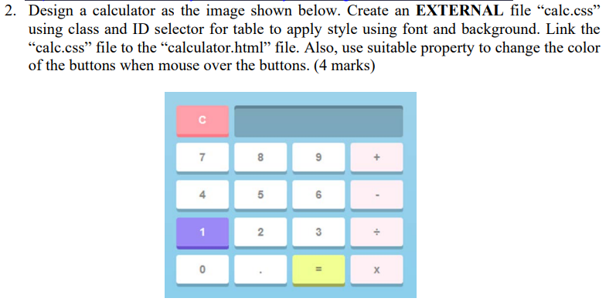

Code:

HTML

<!DOCTYPE html>

<html lang="en">

<head>

    <meta charset="UTF-8">

    <meta name="viewport" content="width=device-width, initial-scale=1.0">

    <title>23BCE1728</title>

    <link rel="stylesheet" type="text/css" href="ex2.css">

</head>

<body>

    <h1>Exercise 6B</h1>

    <div id="container">

        <div class="rows">

            <div class="button" id="clear"><span>C</span></div>

            <div class="screen" id="screen"></div>

        </div>

        <div class="rows">

            <div class="button" id="seven"><span>7</span></div>

            <div class="button" id="eight"><span>8</span></div>

            <div class="button" id="nine"><span>9</span></div>

            <div class="button" id="add"><span>+</span></div>

        </div>

        <div class="rows">

            <div class="button" id="four"><span>4</span></div>

            <div class="button" id="five"><span>5</span></div>

            <div class="button" id="six"><span>6</span></div>

            <div class="button" id="subtract"><span>-</span></div>

        </div>

        <div class="rows">

            <div class="button" id="one"><span>1</span></div>

            <div class="button" id="two"><span>2</span></div>

            <div class="button" id="three"><span>3</span></div>

            <div class="button" id="divide"><span>&divide;</span></div>

        </div>

        <div class="rows">

            <div class="button" id="zero"><span>0</span></div>

            <div class="button" id="decimal"><span>.</span></div>

            <div class="button" id="equal"><span>=</span></div>

            <div class="button" id="multiply"><span>x</span></div>

        </div>

    </div>

</body>

</html>

CSS

#container{

    width: 300px;

    height: 270px;

    background-color: #9CD2EA;

    padding: 2px;

    display: flex;

    justify-content: center;

    align-items: center;

    flex-direction: column;

}

.rows{

    /* margin: 5px; */

    width: 340px;

    height: 50px;

    display: inline-block;

    /* border: 2px solid black; */

    display: flex;

    justify-content: center;

    align-items: center;

}

.button{

    margin: 0px 5px 0px 5px;

    width: 60px;

    height: 40px;

    border-bottom: 4px solid black;

    border-radius: 4px;

    text-align: center;

}

span{

    display: inline-block;

    vertical-align: middle;

    font-size: 22px;

}

#screen{

    margin: 0px 5px 0px 5px;

    height: 40px;

    border-radius: 4px;

    width: 200px;

    background-color: #7DA7BD;

    border:0px 0px 0px 0px;

    border-top: 3px solid #5B8396;

}

#zero,#decimal,#two,#three,#four,#five,#six,#seven,#eight,#nine{

    background-color: #FFFFFF;

    border-color: #619db8;

}

#one{

    background-color: #9B89F7;

    border-color: #6A53D2;

}

#add,#subtract,#divide,#multiply{

    background-color: #FDF1F5;

    border-color: #619db8;

}

#equal{

    background-color: #F2FF93;

    border-color: #9AA14F;

}

#clear{

    background-color: #FFA0AB;

    border-color: #ff576b;

}

Output:

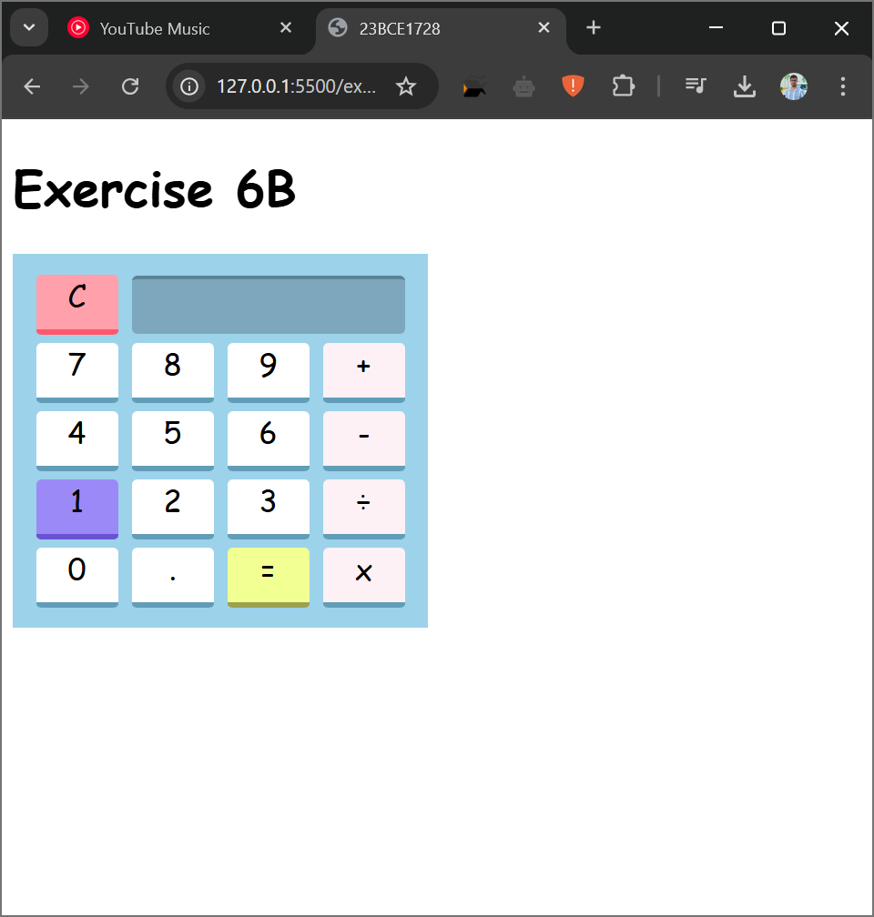

Question 3:

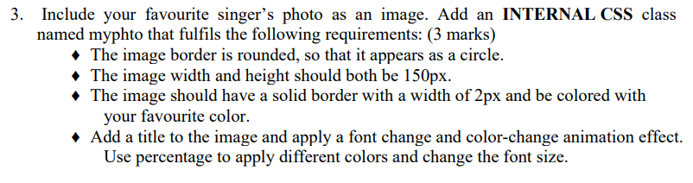

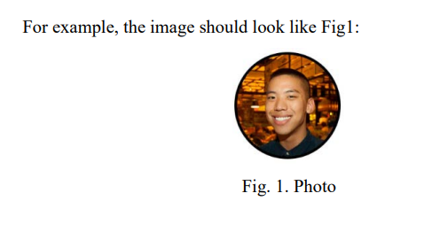

Code:

<!DOCTYPE html>

<html lang="en">

<head>

    <meta charset="UTF-8">

    <meta name="viewport" content="width=device-width, initial-scale=1.0">

    <title>23BCE1728</title>

    <style>

        img{

            width:150px;

            height:150px;

            border: 2px solid #000;

            border-radius: 50%;

        }

        @keyframes textAnimation{

            0%{

                color: #F4F7BE;

                font-size: 40px;

            }

            20%{

                color: #E5F77D;

                font-size: 30px;

            }

            40%{

                color: #DEBA6F;

                font-size: 20px;

            }

            60%{

                color: #823038;

                font-size: 20px;

            }

            80%{

                color: #1E000E;

                font-size: 30px;

            }

            100%{

                color: #F4F7BE;

                font-size: 40px;

            }

        }

        h3{

            animation: textAnimation;

            animation-duration: 2s;

            animation-iteration-count: infinite;

            animation-timing-function: linear;

        }

        div{

            border: 2px solid white;

            height: 120px;

            text-align: center;

        }

    </style>

</head>

<body *align*="center">

    <h1>Exercise 6C</h1>

    <div>

        <h3>Jxggi - The Foul Play</h3>

    </div>

    <img src="jxggi.jpg" alt="">

</body>

</html>

Output:

